Time Recording

BEN stands for Business Engine Network. BEN is time capturing tool which is customized to meet the Tesco needs. BEN provides a better way to distribute and manage information and make your everyday tasks easier.
Some of the functions of BEN are as follows
- It is a project Management tool
- All IT/.COM resources are expected to fill in the Timesheets on a weekly basis.
- This helps in capturing the actual hours spent on different project for each resource
- Enables the manager to allocate different tasks to the resources
- Ensures accurate billing.

Process Steps for Time Recording
The following are the process steps for time entry and approval, and missing timesheet management. The steps include entry or updating of time on timesheets, monitoring missing timesheets, and approving or rejecting timesheets.

Steps to enter time in BEN

- Type in BEN in internet explorer

- On the log in screen, fill in the User name & password (the details will be provided by the respective managers)

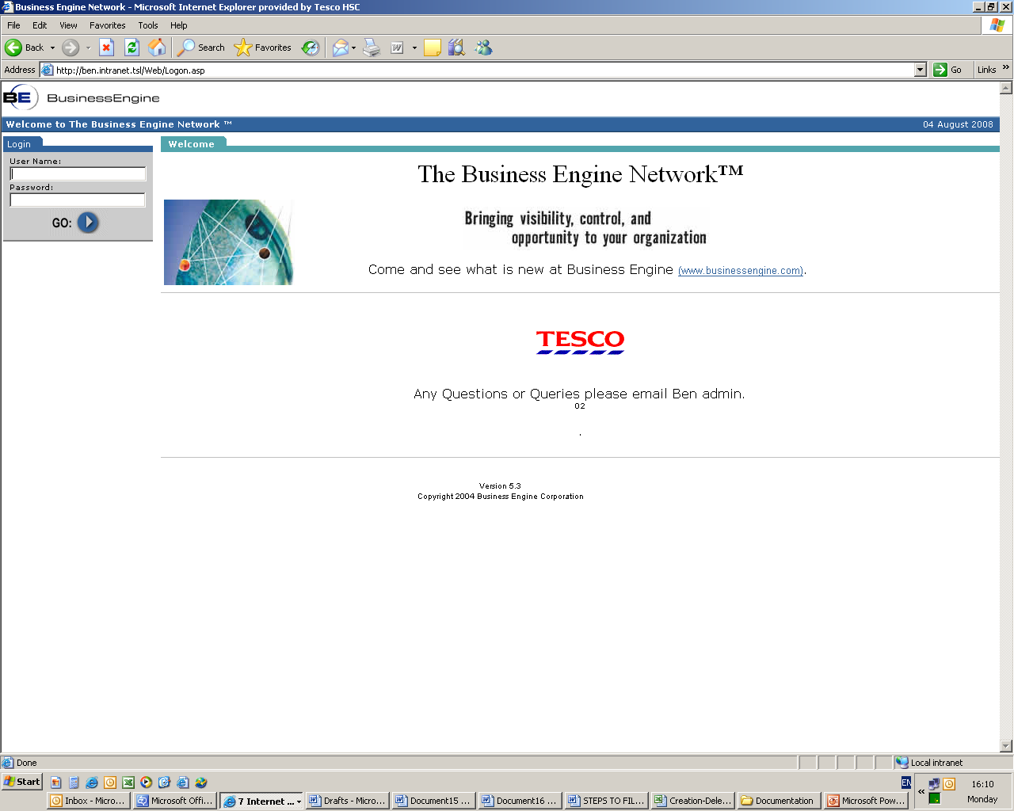

- Click on the particular w/e date to open the time sheets

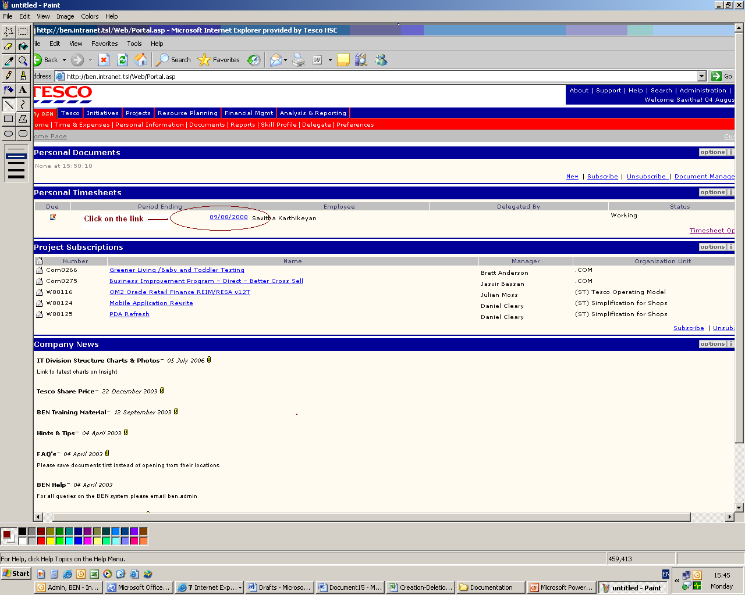

- Below is the time sheet format.
- Fill in the hours against the project assigned. Click Submit.

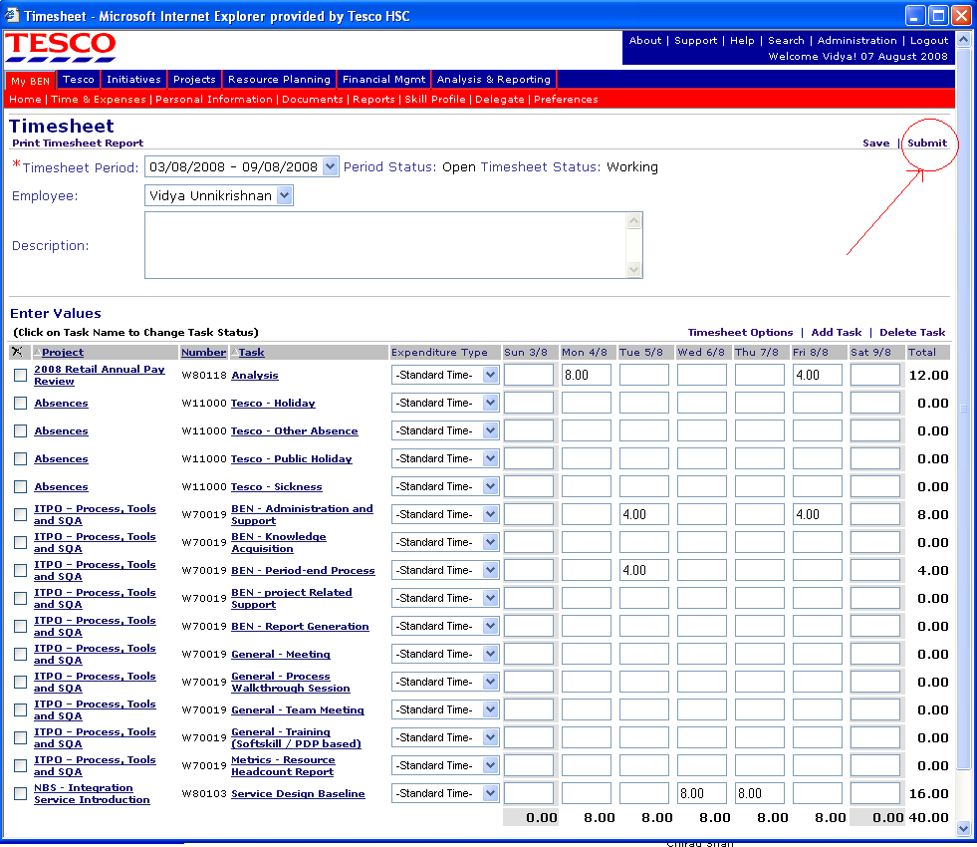

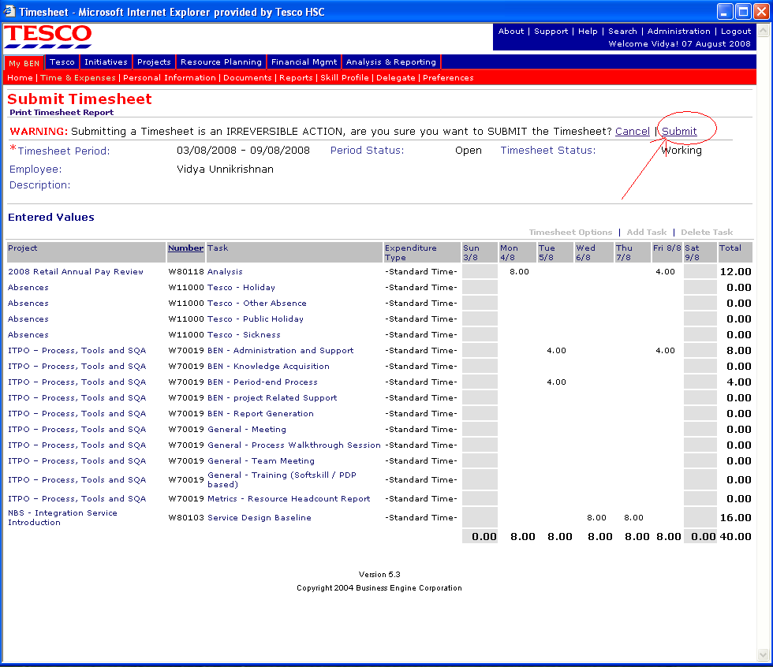

- Once the timesheet have been submitted, the status changes from ‘Working’ to ‘Submitted’.

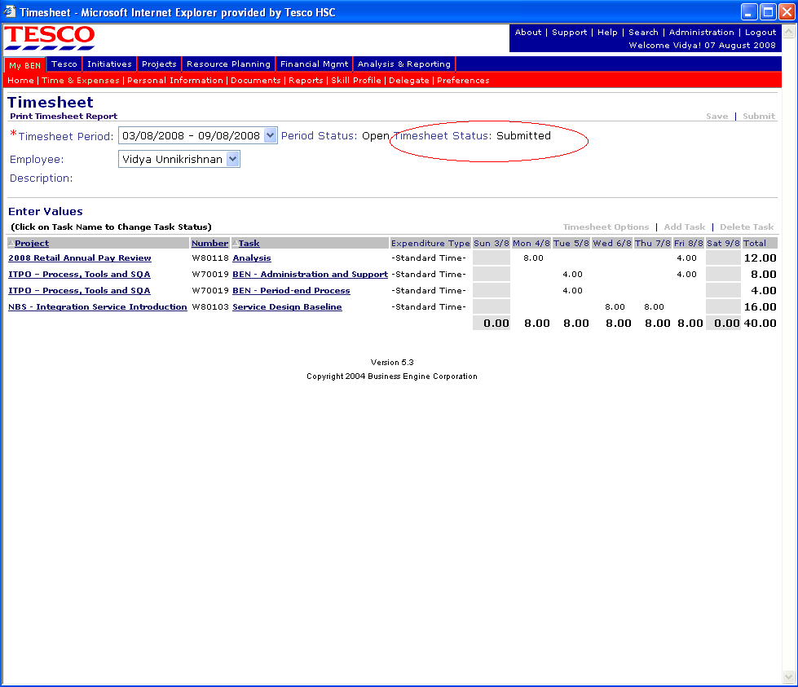

- Click on the second ‘submit option’ to complete the time sheet submission for approval
Team Members
- Enter time for a new timesheet period, or update a timesheet if it has been rejected or needs correction.
My BEN | Personal Timesheets Channel | Period Ending Date

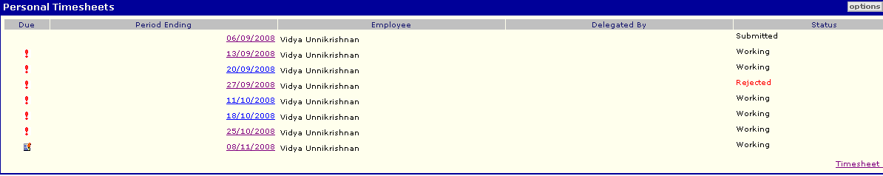

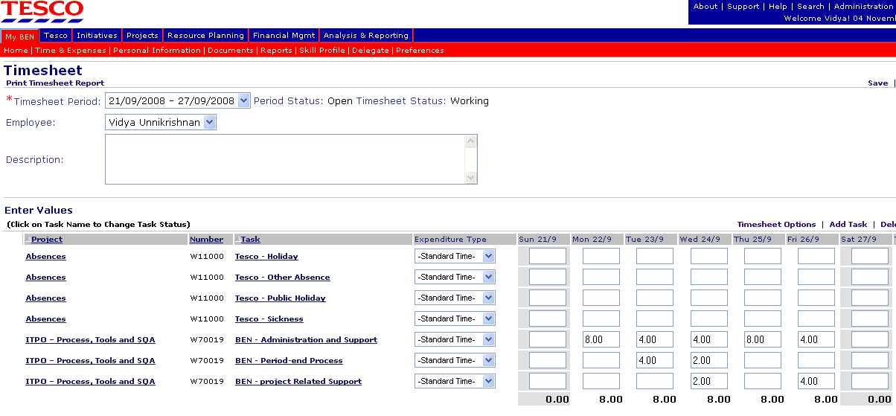

- Timesheets are generated weekly, Sunday through Saturday. Although timesheets are still only due on a period basis, the timesheets should be completed and submitted on a weekly basis.
- Best Practice is that all hours worked should be logged
- Timesheets should be submitted at the latest by Friday 12:00Noon.
- If Approved Overtime is to be logged – Click on the drop down under Expenditure Type next the relevant task line and amend the Expenditure Type to 'Overtime 1', 'Overtime 1.5' or 'Overtime 2' as appropriate and save the task or whole timesheet with a description for Overtime. The description is a must for any overtime or missed hours.

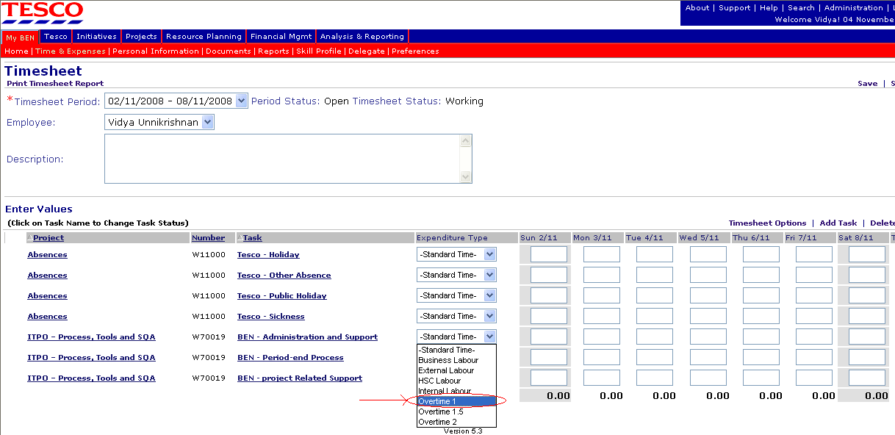

- Submit Timesheets Weekly
- If all tasks are on timesheet and time entered OK, submit the timesheet.
- Request Project Manager or SPM to assign resource to a task
- Task is required on timesheet.
- Timesheets which are not Submitted or Approved appears as Missing Timesheets. Weekly report is generated in order to capture the defaulters.
Some Do’s & Don’ts while you & your team enters time in BEN timesheets:

- Always select Standard Time under the heading Expenditure Type unless to be booked under Overtime.

- Project Manager needs to assign tasks to the resources; similarly unassign them from the projects who are not working for the project. Ben Admin is not responsible for assigning the tasks to the resources other than Absences.

- Please avoid missing booking time. If a resource has missed booking time at the period closure then they will have to book it in the next period as over time with the detailed description.

The missed hours can be booked against a task with expenditure type Overtime1 with a description for the overtime entered.
These hours are charged at the normal rate and no extra charges are applied.

